Solution Report – Assignment 1.

1. Start Hadoop single node on AcadGild VM. The command is start-all.sh.

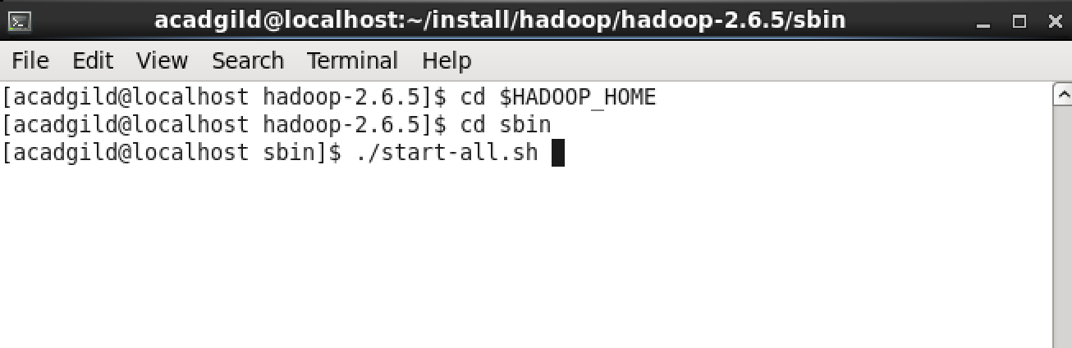

1. Run a JPS command to see if all Hadoop daemons are running.

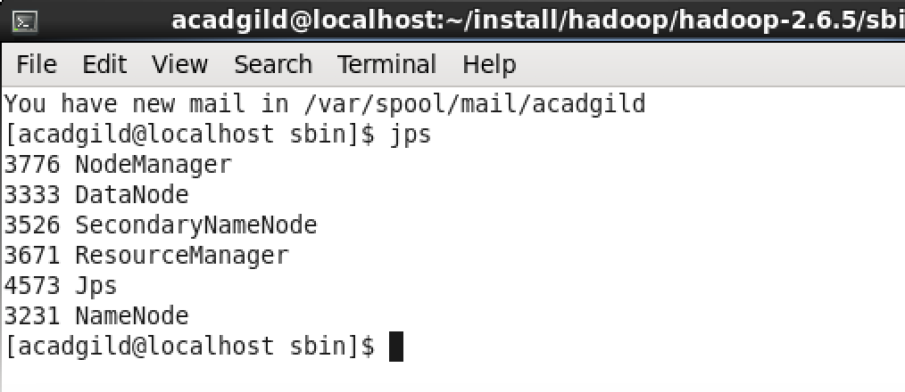

1. Run few Unix commands like pwd, ls -ls, etc.

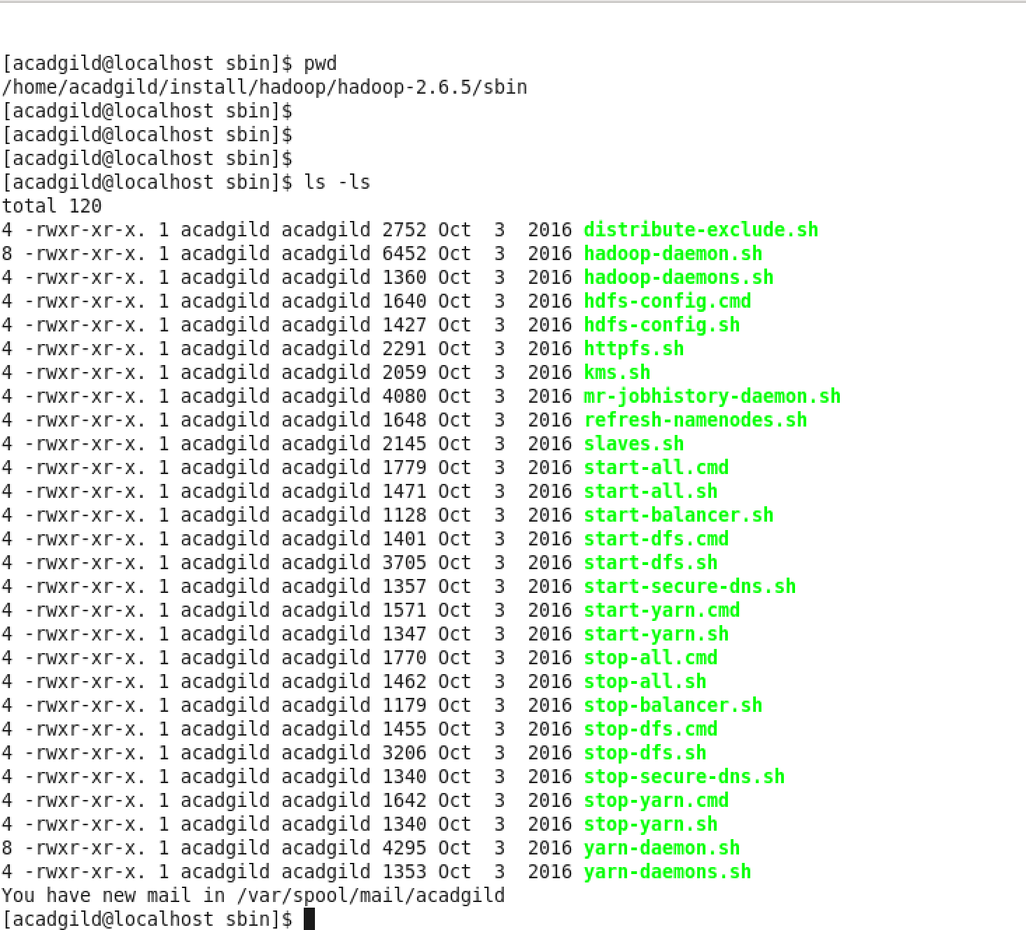

4) Create a file from the terminal using nano editor (example: nano test.txt), and add

some content in it. Cat it to see if the content is saved.

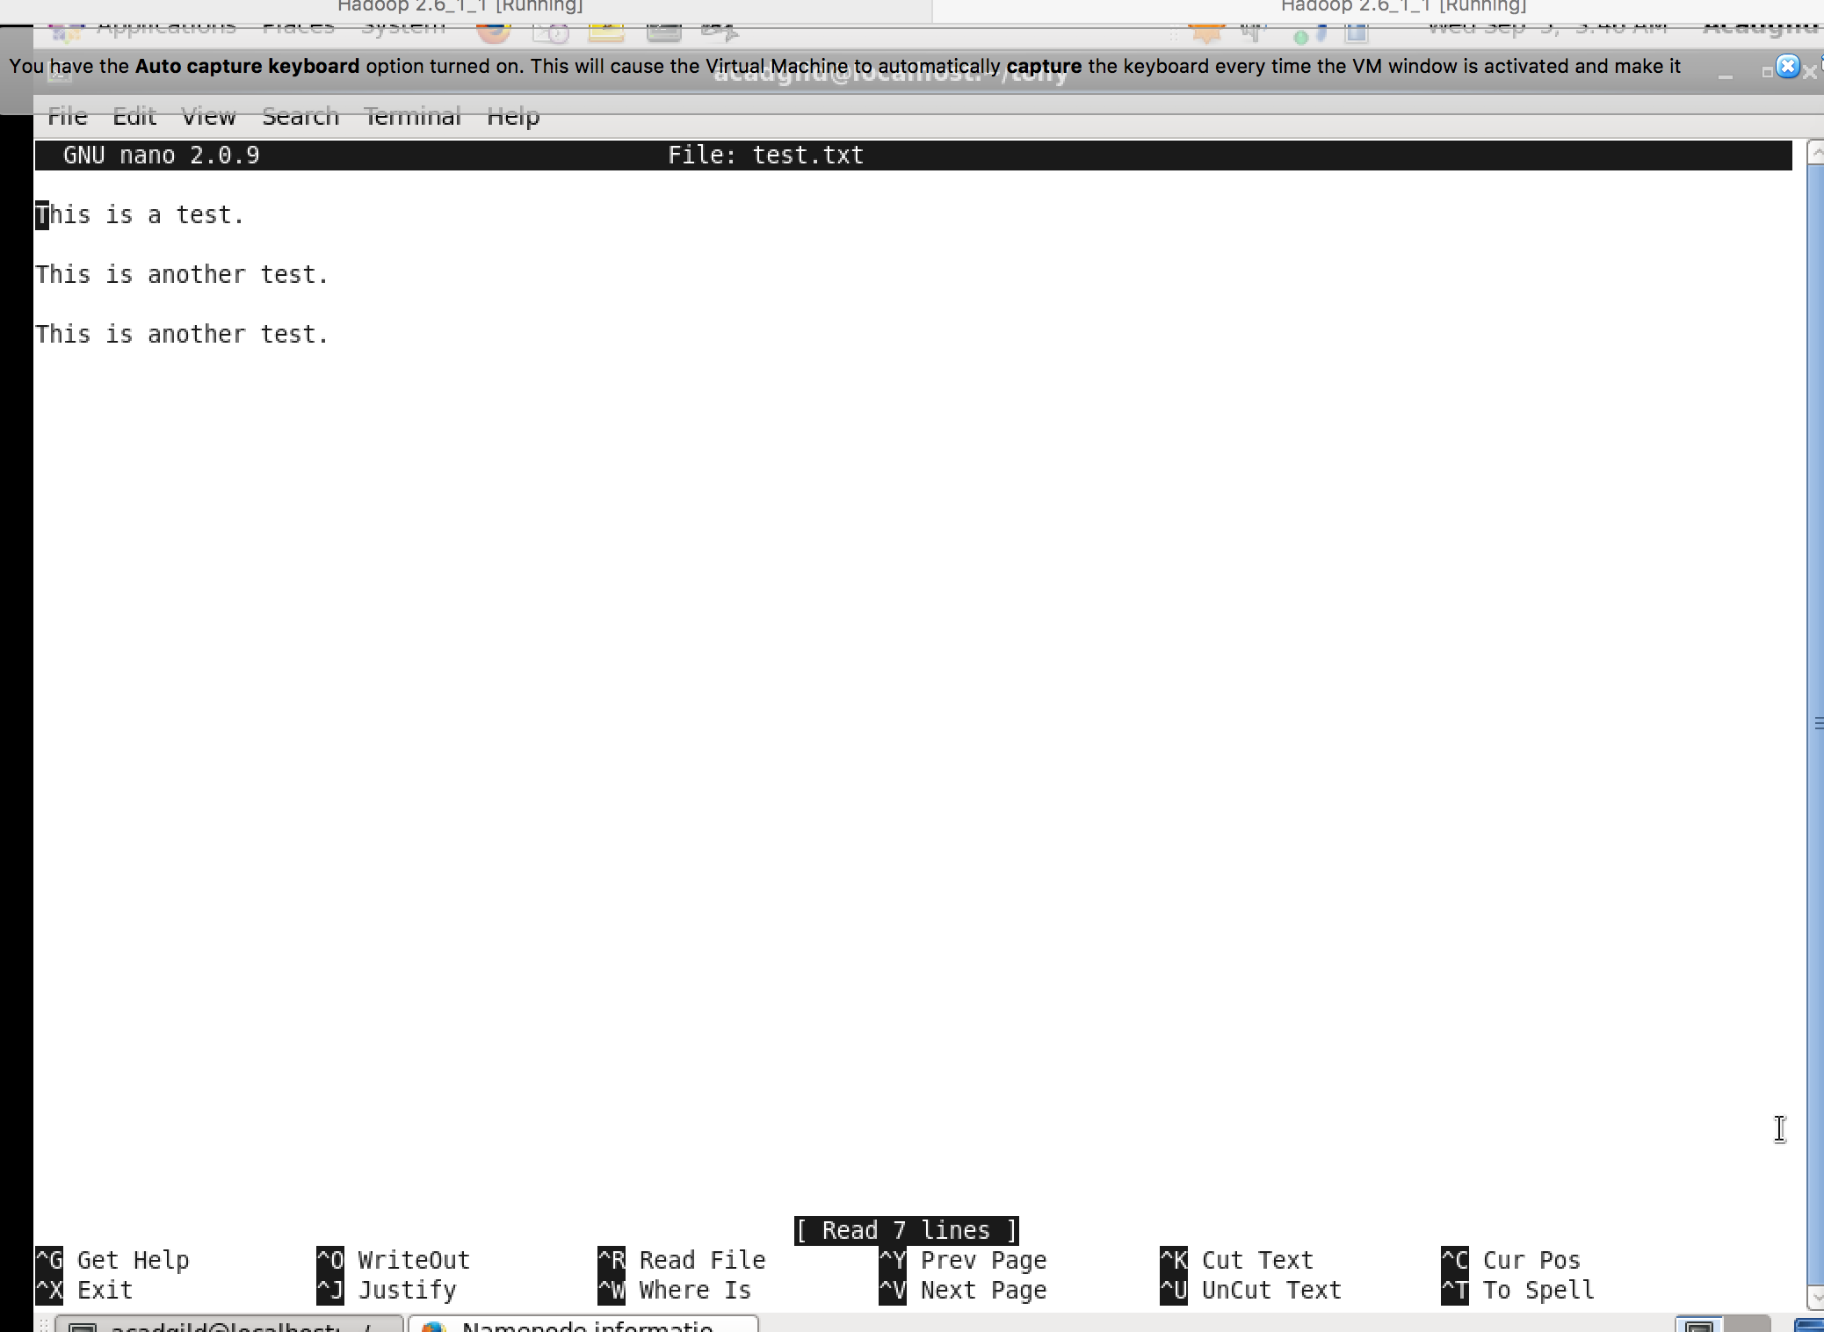

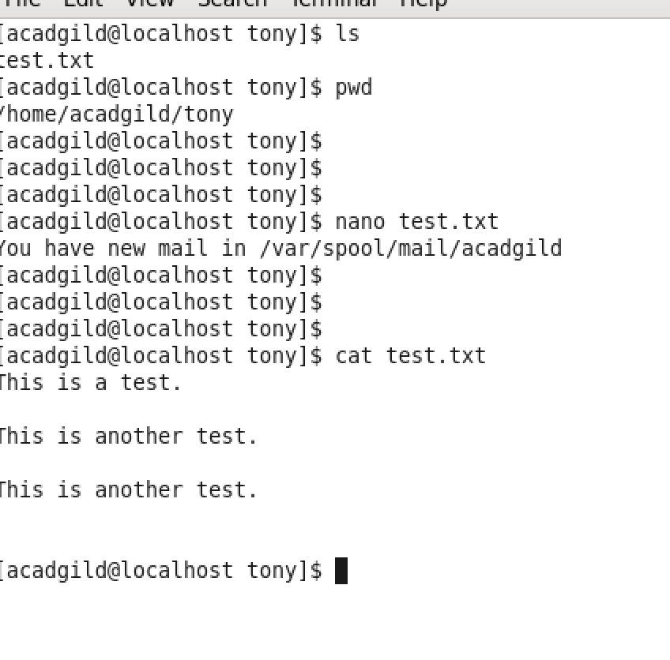

5)Open the hdfs web page by typing localhost:50070 in the browser. Check all the

details of the HDFS.

